Peri-operative Management of Diabetes in Non-pregnant Adults
Document type: Organisational Procedure | Current version: January 2023
Previous version: December 2019 | Next review date: January 2026
This document is relevant to practice at all WH sites, EXCEPT Bacchus Marsh and Melton at this stage

1. Overview
This procedure outlines the peri-operative diabetes management of non-pregnant adults with diabetes mellitus for medical, nursing and pharmacy staff.

For peri-operative diabetes management during pregnancy refer to Type 1 and Type 2 Diabetes Mellitus in Pregnancy; for paediatric patients refer to Paediatric endocrinologist on-call for individualised management advice; for patients using continuous subcutaneous insulin infusion (CSII) pumps refer to Patient Controlled Continuous Subcutaneous Infusion of Insulin (CSII or Insulin Pump) in the Inpatient Setting.

2. Applicability
This procedure applies to all Western Health medical, nursing and pharmacy staff involved in the management of patients in the peri-operative setting.

3. Responsibility
Head of Endocrinology & Diabetes is responsible for the development and review of this guideline.
Medical, nursing and pharmacy staff caring for patients with diabetes undergoing surgery must be aware of and comply with this guideline. Peri-operative diabetes care is primarily the responsibility of the admitting Unit with input from anaesthetists, Pre-Admission Clinic and the Endocrinology & Diabetes Unit as required.

4. Authority
Anaesthetists, ICU medical staff and medical staff of Endocrinology & Diabetes Unit may vary this procedure at their discretion.

5. Associated Documentation
In support of this procedure, the following Manuals, Policies, Instructions, Guidelines, and/or Forms apply:
Code | Name
 | Capillary Blood Ketone Testing in Diabetes Mellitus Across All Age Groups
 | Diabetes Management in Non-pregnant Adult Patients with COVID19 Infection
 | Diabetic Ketoacidosis (DKA) Management in Adults
 | Hypoglycaemia Management in Adults with Diabetes
 | Insulin Infusion (Intravenous) in Adults
 | Insulin Prescription, Supply, Storage and Administration
 | Intravenous Therapy (IVT) Management
 | Management of Children (< 18 years) with Diabetes Mellitus on Insulin Therapy requiring Surgery
 | Medication Prescription, Supply, Storage and Administration
 | Medication Use and Management
 | Patient Controlled Continuous Subcutaneous Infusion of Insulin (CSII or Insulin Pump) in the Inpatient Setting
 | Type 1 and Type 2 Diabetes Mellitus in Pregnancy

6. Credentialing Requirements
No specific credentialing requirements.

7. Definitions and Abbreviations

7.1 Definitions
For purposes of this procedure, unless otherwise stated, the following definitions shall apply:
Adult | Any patient 18 years of age or older.
Insulin Treated Diabetes Mellitus | A patient with any diabetes diagnosis (e.g. Type 1 Diabetes Mellitus, Type 2 Diabetes Mellitus, steroid-induced diabetes; pancreatogenic diabetes type 3c) who uses insulin on a regular, daily basis.
Short-acting Insulin | Insulin with a duration of action of up to 8 hours (e.g. Novorapid, Humalog, Apidra, Fiasp, Actrapid).
Long-acting Insulin | Insulin with duration of action of 12 to 24 hours (e.g.Optisulin (previously known as Lantus), Levemir, Toujeo, Protaphane).
Mixed Insulin | Insulin containing both short and long-acting insulin (e.g. NovoMix, Humalog Mix, Ryzodeg, Mixtard). NB. Ryzodeg contains Degludec as the long acting insulin component, which is longer acting than Protaphane (similar to glargine)
Non-insulin Injectable Hypoglycaemic Agent | Injectable hypoglycaemic agent excluding insulin (GLP1 analogue e.g. Exenatide, Dulaglutide, Semaglutide, Liraglutide)
Oral Hypoglycaemic Agent | Any oral medication for diabetes (e.g. metformin, sulphonylureas, thiazolidinediones, acarbose, DPP-4 inhibitors, SGLT2 inhibitors).
Peri-operative Period | The time period immediately before, during and following a surgical operation.
SGLT2 inhibitors | Sodium-Glucose Co-Transporter 2 inhibitors e.g. dapagliflozin (Forxiga), empagliflozin (Jardiance), ertugliflozin (Steglatro), may be combined with metformin (Xigduo, Jardiamet, Segluromet), or with DPP-4 inhibitors (Glyxambi, Qtern, Steglujan).
DPP-4 inhibitors | Dipeptidyl Peptidase-4 inhibitors e.g. alogliptin, linagliptin, saxagliptin, sitagliptin, vildagliptin, may be combined with metformin or with DPP-4 inhibitors.

7.2 Abbreviations
For purposes of this guideline, unless otherwise stated, the following abbreviations shall apply:
ABG | Arterial Blood Gas
BGL | Blood Glucose Level (as assessed by capillary finger-prick)
DKA | Diabetic Ketoacidosis
ENT | Ears, Nose and Throat
GLP-1 | Glucagon-Like Peptide-1 Receptor
HMO | Hospital Medical Officer
ICU | Intensive Care Unit
OHA | Oral Hypoglycaemic Agent
SGLT2 | Sodium-Glucose Co-transporter 2
T1DM | Type 1 Diabetes Mellitus
T2DM | Type 2 Diabetes Mellitus
VBG | Venous Blood Gas

8. Procedure Detail

8.1 Rationale
Rationale:
- Western Health has a high prevalence of diabetes, with approximately one third of inpatients having known diabetes¹. Of these, 40% are treated with insulin with or without other agents.
- Surgery and anaesthesia can cause a neuroendocrine stress response, with increased levels of adrenaline, glucagon, cortisol and growth hormone all of which may increase insulin resistance, reduce peripheral glucose utilisation, impair insulin secretion and increase lipolysis, resulting in hyperglycaemia.²⁻³
- Peri-operative hyperglycaemia is associated with poor outcomes including increased infections, length of stay and delayed wound healing.⁴⁻⁶
- Fasting for surgery may induce ketosis, particularly in T1DM.
- Fasting may increase the risk of hypoglycaemia in patients treated with diabetes medications.
- Fasting may increase the risk of diabetic ketoacidosis in patients with T2DM using SGLT2 inhibitors and this can be in association with near normal or only mildly elevated blood glucose levels (“euglycaemic ketoacidosis”).⁷
- To minimise adverse outcomes, target range BGL during the peri-operative period is generally 5-12 mmol/L.

8.2 Pre-operative Assessment

8.2.1 Clarification of Diagnosis and Treatment
- Efforts should be made to identify if a patient has Type 1 diabetes or Type 2 diabetes and this should be clearly documented in the notes.
- All diabetes medications and doses should be documented in full. When documented in the EMR, they should be entered as a home medication (this has relevant fields to prompt more complete documentation) and not simply typed in a progress note.
- Make a note if medications are managed by the patient’s local pharmacy as this will affect who to contact regarding diabetes medication adjustments required preoperatively.
- A recent (3 months or less) HbA1c should be documented for all patients with diabetes mellitus whenever possible. If a result is unavailable, request HbA1c at the Pre-admission clinic visit. If the HbA1c result is above 9% (75 mmol/mol) consider deferring non-urgent surgery and refer to the Rapid Access Diabetes Clinic (contact Endocrinology Registrar for details) for diabetes optimisation prior to surgery.
- Any history of congestive cardiac failure or fluid restriction should be documented.

8.2.2 Documentation
- All patients treated with any diabetes medication (oral or injectable) should have a documented peri-operative diabetes management plan at the time of Pre-admission clinic assessment.
- In the EMR, the plan is found under ‘Documentation’. The PAC notes are filed under ‘PAC’, so by using a filter for PAC, these notes can be readily found.
- Peri-operative insulin advice is generally provided by anaesthetic medical staff in Pre-Admission clinic. The Endocrinology Registrars should be advised of patients with type 1 diabetes who are booked for elective surgery or who are admitted for urgent surgery, so that they can help with diabetes management once admitted. Pharmacists document patient medications on EMR from Pre-Admission Clinic. All peri-operative plans should be clearly documented and readily accessible in the EMR.
- Patients should be provided with written instructions by Pre-admission staff wherever possible on how to manage their diabetes medications prior to surgery. It is recognised that at times this is not possible as the advice for insulin treated patients is usually given by medical staff by phone, close to the date of surgery, which gives insufficient time for written advice to reach the patient.
- If the medication is managed by the local pharmacy (e.g. blister packs), the pharmacy should be contacted to make the appropriate preoperative medication adjustments to the packs.

8.2.3 Surgical Booking of Patients with Diabetes
- The following patients should be booked first on the morning surgical list or as early in the day as practicable to reduce fasting times:
  - Patients with diabetes treated with insulin.
  - Patients with diabetes treated with SGLT2 inhibitors who will continue their SGLT2 inhibitor (same day procedures with routine fasting).

8.3 Management in the Days Prior to Procedure

8.3.1 Same Day Procedures (without bowel preparation)
- Take all diabetes medications (including insulin, GLP-1 analogues (semaglutide, Ozempic ® and dulaglutide, Trulicity ® and SGLT2 inhibitors) as usual in the days leading up to the procedure.
- An exception to this are day procedures where it is anticipated that there will be limited eating for several days post-operatively (e.g. maxillo-facial/ENT surgery). In these cases consult with the Endocrinology & Diabetes Unit as it may be necessary to cease SGLT2 inhibitors for 72 hours before surgery.

8.3.2 Any Procedures Requiring Bowel Preparation
- Withhold SGLT2 inhibitors (including those in fixed dose combinations with DPP4 inhibitors or metformin) for 2 full days prior to the procedure and the day of the procedure (i.e. take the last dose of SGLT2 inhibitor 72 hours prior to the morning of procedure).
- A reduced dose of other diabetes medication is required 1 day before the scheduled procedure. See Table 1 below for instructions.
- Patients should be informed of the risk of elevated BGL during this period. Patients should be told to continue monitoring their BGL as they normally do and to seek medical advice if their BGL is over 15 mmol/L on two occasions in a 24-hour period (see Appendix B for suggestions on treatment if this occurs).
- For details regarding specific colonoscopy diabetes management, please see: http://inside.wh.org.au/departmentsandservices/EndoscopyServices/Documents/Colonoscopy%20diabetes%20guidelines%202019.pdf.

Table 1: Medication instructions for the DAY BEFORE any PROCEDURE REQUIRING BOWEL PREPARATION
Medication | Instructions for the day before procedure
Oral hypoglycaemic agents | Withhold
Non-insulin injectable hypoglycaemic agents (GLP-1 agonists) | Withhold
Short-acting insulin  (e.g. Fiasp, NovoRapid, Humalog, Apidra, Actrapid) | Morning dose:  For any insulin injection, give half the usual dose with light breakfast  For insulin pumps, do not change basal rates. Bolus as usual  Midday dose:  If short-acting insulin is usually taken at this time, test BGL  - For BGL < 10 mmol/L = withhold  - For BGL ≥ 10 mmol/L = give half usual dose  For insulin pumps, do not change basal rates. If BGL > 15 mmol/L, give the suggested correction dose  Evening dose:  If long-acting insulin is usually taken at this time, give usual full dose  If mixed or short-acting insulin is usually taken at this time, test BGL  - For BGL ≥ 10 mmol/L = give half usual dose  - For BGL between 5.0 and 10.0 mmol/L = give a quarter (25%) of usual dose  - For BGL < 5 mmol/L = withhold  For insulin pumps, do not change basal rates. If BGL > 15 mmol/L, give the suggested correction dose
Long-acting insulin
(e.g. Optisulin (previously known as Lantus, insulin glargine), Levemir, Toujeo, Protaphane)
Mixed insulin
(e.g. NovoMix 30, Mixtard, HumalogMix 25 or HumalogMix50, Ryzodeg)
Insulin not listed above | Please consult Endocrinology Registrar

8.3.3 All Other Procedures (without bowel preparation)
- Withhold SGLT2 inhibitors (including those in fixed dose combinations with DPP4 inhibitors or metformin) for 2 full days prior to the procedure and the day of the procedure (i.e. take the last dose of SGLT2 inhibitor 72 hours prior to the morning of surgery). (see Appendix A)
- Take all other diabetes medications as usual, until the day of the procedure.
- Patients should be informed of the risk of elevated BGL during this period. Patients should be told to continue monitoring their BGL as they normally do and to seek medical advice if their BGL is over 15 mmol/L on two occasions in a 24-hour period (see Appendix B).

8.4 Management on the Day of the Procedure for All Patients with Diabetes

8.4.1 Medication Management
- Withhold all non-insulin diabetes medications (Oral Hypoglycaemic Agents and non-insulin injectable hypoglycaemic agents i.e. GLP-1 agonists)
- Check fingerprick ketones on admission and at least every six hours in all patients with type 1 diabetes and in those with type 2 diabetes who have not withheld the SGLT2 inhibitor for at least 72 hours
- For patients who normally use insulin, see Table 2 below for instructions.
- For patients who use a continuous subcutaneous insulin infusion (CSII) pump at home: refer to Patient Controlled Continuous Subcutaneous Infusion of Insulin (CSII or Insulin Pump) in the Inpatient Setting.

Table 2: Instructions for insulin on day of procedure
Medication | Instructions for day of procedure
Short-acting insulin  (e.g. Fiasp, NovoRapid, Humalog, Apidra, Actrapid) | Morning list: withhold  Afternoon list: give half usual dose with light breakfast
Long-acting insulin  (e.g. Optisulin (previously known as Lantus), insulin glargine, Levemir, Toujeo)  Protaphane | If long-acting insulin is taken once daily in the evening, give usual long acting dose the night before procedure.  If long-acting is usually taken once daily in the morning, give usual morning dose on the morning of the procedure.  If long-acting insulin is taken twice daily, give usual dose the night before, but only half the dose on the morning of the procedure  If Protaphane is usually taken once daily in the morning, give half the usual morning dose on the morning of the procedure  If Protaphane is taken twice daily, give usual dose the night before, but only half the dose on the morning of the procedure
Mixed insulin  (e.g. NovoMix 30, Mixtard, HumalogMix 25 or HumalogMix50, Ryzodeg) | Morning list: Patient to be advised to withhold their normal morning insulin. Give half their usual morning pre-mixed insulin dose as Protaphane instead on arrival to Admissions area, as the patient will not have any Protaphane available at home for them to give before arrival at the hospital. Page relevant Unit HMO to chart Protaphane, if it has not already been ordered in the EMR  Afternoon list: patient should take half their usual morning dose of mixed insulin with light breakfast at home
Insulin not listed above | Please consult Endocrinology Registrar

8.4.2 Patients Who Have Not Ceased their SGLT2 Inhibitor Preoperatively
- Strongly consider postponing non-urgent procedures if SGLT2 inhibitors have not been withheld for 2 full days prior to the procedure and the day of the procedure (i.e. last dose of SGLT2 inhibitor taken less than 72 hours prior to the morning of surgery) if the procedure:
  - Requires an overnight stay; and
  - Is expected to be associated with a delayed return to normal diet.
- A decision to proceed with non-urgent surgery should be made in consultation with the treating team, the Endocrinology & Diabetes Unit and the patient. A plan for increased BGL and ketone monitoring post-operatively is required if the patient proceeds with the planned procedure. This should be discussed with the Endocrinology & Diabetes Unit.

8.4.2.1 For Emergency Surgery which cannot be Safely Postponed
- Ketone assessment and management:
  - Document cessation of SGLT2 inhibitors on admission and do not restart until eating normally
  - Fingerpick blood ketones and blood glucose should be measured hourly during the procedure and second hourly following the procedure until eating and drinking normally.
  - If blood ketones are greater than 1.0 mmol/L at any time, venous pH (VBG) should be measured:
    - If pH ≥7.30, the elevated ketones may reflect starvation ketosis combined with the effect of SGLT2i. If the patient is unlikely to resume normal eating and drinking within 2 hours:
      - An intravenous insulin infusion with concomitant 5% glucose intravenous infusion should be commenced to prevent progression to ketoacidosis
      - An alternative approach would be the administration of subcutaneous insulin and a concomitant 5% glucose intravenous infusion
      - Discussion with the Endocrinology & Diabetes Unit is recommended
      - Hourly monitoring of fingerpick blood ketones and glucose should continue until resumption of normal diet.
    - If pH < 7.30, the clinician should consider the possibility of ketoacidosis and commence appropriate treatment according to the procedure: OP-CC4 Diabetic Ketoacidosis (DKA) Management in Adults. Consultant Anaesthetist and Endocrinology & Diabetes Unit input should be urgently obtained.

8.4.3 Monitoring of Blood Glucose and Ketones
- Patients should have BOTH their admission BGL AND ketone level checked using point-of-care devices via finger prick. This should be recorded on the Passport to Surgery (AD 250) document or EMR replacement and in the Blood Glucose Level Monitoring section of EMR.
- Any blood ketone level > 1.0 mmol/L requires notification to the surgical unit HMO the patient’s VBG should be checked urgently. If pH < 7.30, notify the endocrinology registrar for assessment of possible diabetic ketoacidosis which is a medical emergency.
- It should be noted that patients treated with SGLT2 inhibitors may not have elevated blood glucose, but can still develop diabetic ketoacidosis (“euglycaemic diabetic ketoacidosis”).
- BGL should be checked every 2 hours preoperatively.
- Any BGL > 18 mmol/L requires fingerpick ketones to be checked immediately (see Capillary Blood Ketone Testing in Diabetes Mellitus Across All Age Groups for further information about capillary blood ketone testing) and then notify Endocrinology Registrar with the result.
- If diabetic ketoacidosis is present refer to Diabetic Ketoacidosis (DKA) Management in Adults.

8.4.4 Preoperative Carbohydrate Drinks
- Preoperative carbohydrate drinks may result in hyperglycaemia. If a patient has consumed preoperative carbohydrate drinks and has a BGL > 18 mmol/L, please notify the Endocrinology Registrar immediately.
- Preoperative carbohydrate drinks should be avoided in Type 1 patients with diabetes.
- Preoperative carbohydrate drinks should be avoided in Type 2 patients with diabetes who have a BGL over 10 mmol/L prior to consuming.

8.4.5 Management of Preoperative Hypoglycaemia (BGL < 4 mmol/L)
- If BGL < 4 mmol/L, notify HMO immediately and refer to Hypoglycaemia Management in Patients with Diabetes for further management.
- A glucose 5% infusion should be administered via an IV infusion pump using the appropriate Alaris Guard-rails profile with the following specifications:
- Commence glucose 5% infusion at a rate of 100 mL/hour.
- Monitor BGL every 15 minutes until BGL is above 4 mmol/L.
- When BGL above 4 mmol/L continue glucose infusion and monitor BGL every 2 hours.
- Cease glucose infusion if BGL > 12.0 mmol/L.
- Note: Further information can be found in Hypoglycaemia Management in Adults with Diabetes.

8.4.6 Management of Preoperative Hyperglycaemia
- Administer supplementary NovoRapid® insulin subcutaneously every 4 hours, as required according to Table 3. Do not administer insulin more often than every 4 hours.
- BGL should be checked every 2 hours. If there are two consecutive BGL > 12.0 mmol/L, despite supplemental insulin, page HMO to consult with Endocrinology registrar.

Table 3: Doses of supplemental NovoRapid® insulin for patients with diabetes
BGL  (mmol/L) | Body weight
BGL  (mmol/L) | <60 kg | 60-90 kg | >90 kg
<4 | Call HMO | Call HMO | Call HMO
<12 | 0 | 0 | 0
12.1-16.0 | 4 | 6 | 8
16.1-18.0 | 6 | 8 | 10
>18.0 | Call Endocrinology Registrar | Call Endocrinology Registrar | Call Endocrinology Registrar

8.5 Intraoperative Management
Intraoperative management:
- BGL should be maintained in the range of 5-12 mmol/L.
- BGL should be recorded prior to induction of anaesthesia and monitored regularly throughout surgery (at least 2 hourly).
- If BGL > 12 mmol/L and insulin has been omitted, blood ketone levels should be checked. If blood ketone levels are > 1 mmol/L, ABG or VBG should be taken and the Endocrinology Registrar contacted for advice. Intraoperative hyperglycaemia (BGL > 12 mmol/L) should be treated with subcutaneous short-acting Novorapid® insulin (e.g. Novorapid® up to 6 units: in most people, 1 unit will decrease BGL by approximately 3 mmol/L, but be careful with thin people, or elderly people who may be more insulin sensitive).
- An alternative to subcutaneous insulin is the use of an intravenous NovoRapid® insulin infusion during the course of surgery, in which case at least hourly BGL monitoring is required (for details refer to Insulin Infusion (Intravenous) in Adults).
- After subcutaneous insulin is administered, BGL should be checked hourly. A second dose of subcutaneous insulin should not be given for 4 hours after the first dose, to avoid insulin accumulation with later hypoglycaemia.
- Insulin is a high risk drug for administration errors. All insulin administration in the operating theatres should be double checked by a second person (medical or nursing staff). Where a cartridge is used (all insulin in operating theatres are presented as cartridges), a 50 unit insulin syringe must be used for each injection.
- Intraoperative hypoglycaemia (BGL < 4 mmol/L): 25-50 mL of 50% glucose should be given intravenously and BGL rechecked every 15 minutes until target BGL of 5-12 mmol/L is reached. Further 50% glucose may be required on an individualised basis. Once the target is achieved, check BGL hourly.
- Appropriate anti-emetic prophylaxis should be administered to prevent post-operative nausea and vomiting and enable the patient to resume a normal diet post-operatively:
- The use of dexamethasone or other glucocorticoids should generally be avoided in patients with diabetes due to the increased incidence of postoperative hyperglycaemia and difficulty with BGL control in the postoperative period. Any use of intraoperative glucocorticoids should be recorded in the EMR Medication Administration Record so that ward staff can readily be aware of this intraoperative treatment.

8.6 Post-operative Management
Post-operative management:
- Short term use of supplementary NovoRapid® can continue for the first 24 hours post-operatively (according to Table 3 above), but should not continue after day 1 without the addition of a daily dose of insulin glargine (or alternatively resuming a patient’s usual form of long-acting insulin)
- The initial insulin glargine dose is calculated by adding the dose of all the previous day’s NovoRapid® and giving approximately 80% of that total dose as insulin glargine in the morning. The NovoRapid® supplementary scale may also need adjustment on a case by case basis, depending on how the patient’s BGLs have responded.
- Refer to Endocrinology Unit if a patient with diabetes is likely to continue fasting for more than 24 hours post-operatively.
- Resume regular insulin doses following procedure once eating normally. If not eating normally, reduced insulin doses may be required. In these cases consider referral to the Endocrinology Registrar for advice.
- Resume usual Oral Hypoglycaemic Agents and non-insulin injectable hypoglycaemic agents following surgery, if eating normally.
- SGLT2 inhibitors should only be recommenced once a patient is on full oral intake. If this is going to occur after hospital discharge, it may be necessary to prescribe further supplies of the other component of fixed dose combination therapy (e.g. metformin or DPP-4 inhibitor) in patients who are usually treated with these.

Refer to Appendix C for advice regarding minimising the risk of DKA in SGLT2 inhibitors treated patients

Refer to Appendix D for a summary of the changes required for all diabetes medications at the time of a procedure

9. Document History
Number of previous revisions: 3

Previous issue dates: October 2017, January 2019 and December 2019

Minor amendment: not applicable this version

Documents superseded or combined:
Code | Name
OP-PS1.2.32 | Peri-operative Management of Diabetes in Non-pregnant Adults
OP-GC6 | Perioperative Management of Diabetes in Non-pregnant Adults

10. References
- Bach L, Ekinci E, Engler D et al. The high burden of inpatient diabetes mellitus: the Melbourne Public Hospitals Diabetes Inpatient Audit. MJA 2014. 201 (6) 334-338
- Clarke RS. The hyperglycaemic response to different types of surgery and anaesthesia. Br J Anaesth. 1970; 42:45
- Clarke RS, Johnston H, Sheridan B. The influence of anaesthesia and surgery on plasma cortisol, insulin and free fatty acids. Br J Anaesth 1970; 42:295
- Rosenberg CS, Wound healing in the patient with diabetes mellitus. Nurs Clin North Am. 1990; 25(1): 247-61
- King JT, Goulet JL, Perkal MF & Rosenthal RA. Glycemic control and infections in patients with diabetes undergoing noncardiac surgery. Ann Surg. 2011;253(1):158
- Frisch A, Chandra P, Smiley D et al. Prevalence and clinical outcome of hyperglycemia in the perioperative period in noncardiac surgery. Diabetes Care. 2010;33(8):1783-8. Barker P, Creasey PE, Dhatariya K, Levy N, Lipp A, Nathanson MH et al. Peri-operative management of the surgical patient with diabetes 2015: Association of Anaesthetists of Great Britain and Ireland. Anaesthesia. 2015;70(12):1427-40.
- Hamblin PS, Wong R,Ekinci EI et al. SGLT2inhibitors increase the risk of diabetic ketoacidosis developing in the community and during hospital admission . J Clin Endocrinol Metab 2019;104:3077-308.
- Hamblin PS, Wong R, Bach LA, Sodium–glucose cotransporter type 2 inhibitors: managing the small but critical risk of diabetic ketoacidosis Med J Aust 2020; 212 (7): . || doi: 10.5694/mja2.50525
- ALERT UPDATE July 2022 with SGLT2 Inhibitor Use In People with Diabetes https://diabetessociety.com.au/downloads/20220726%20ADS%20ADEA%20ANZCA%20NZSSD_DKA_SGLT2i_Alert_Ver%20July%202022.pdf

11. Sponsor
Head of Endocrinology and Diabetes

12. Authorisation Authority
Chief Medical Officer

Appendix A

Flowchart on withholding SGLT2 Inhibitors on the Days prior to Procedure

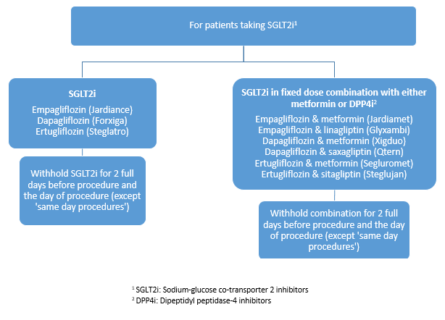

Appendix B
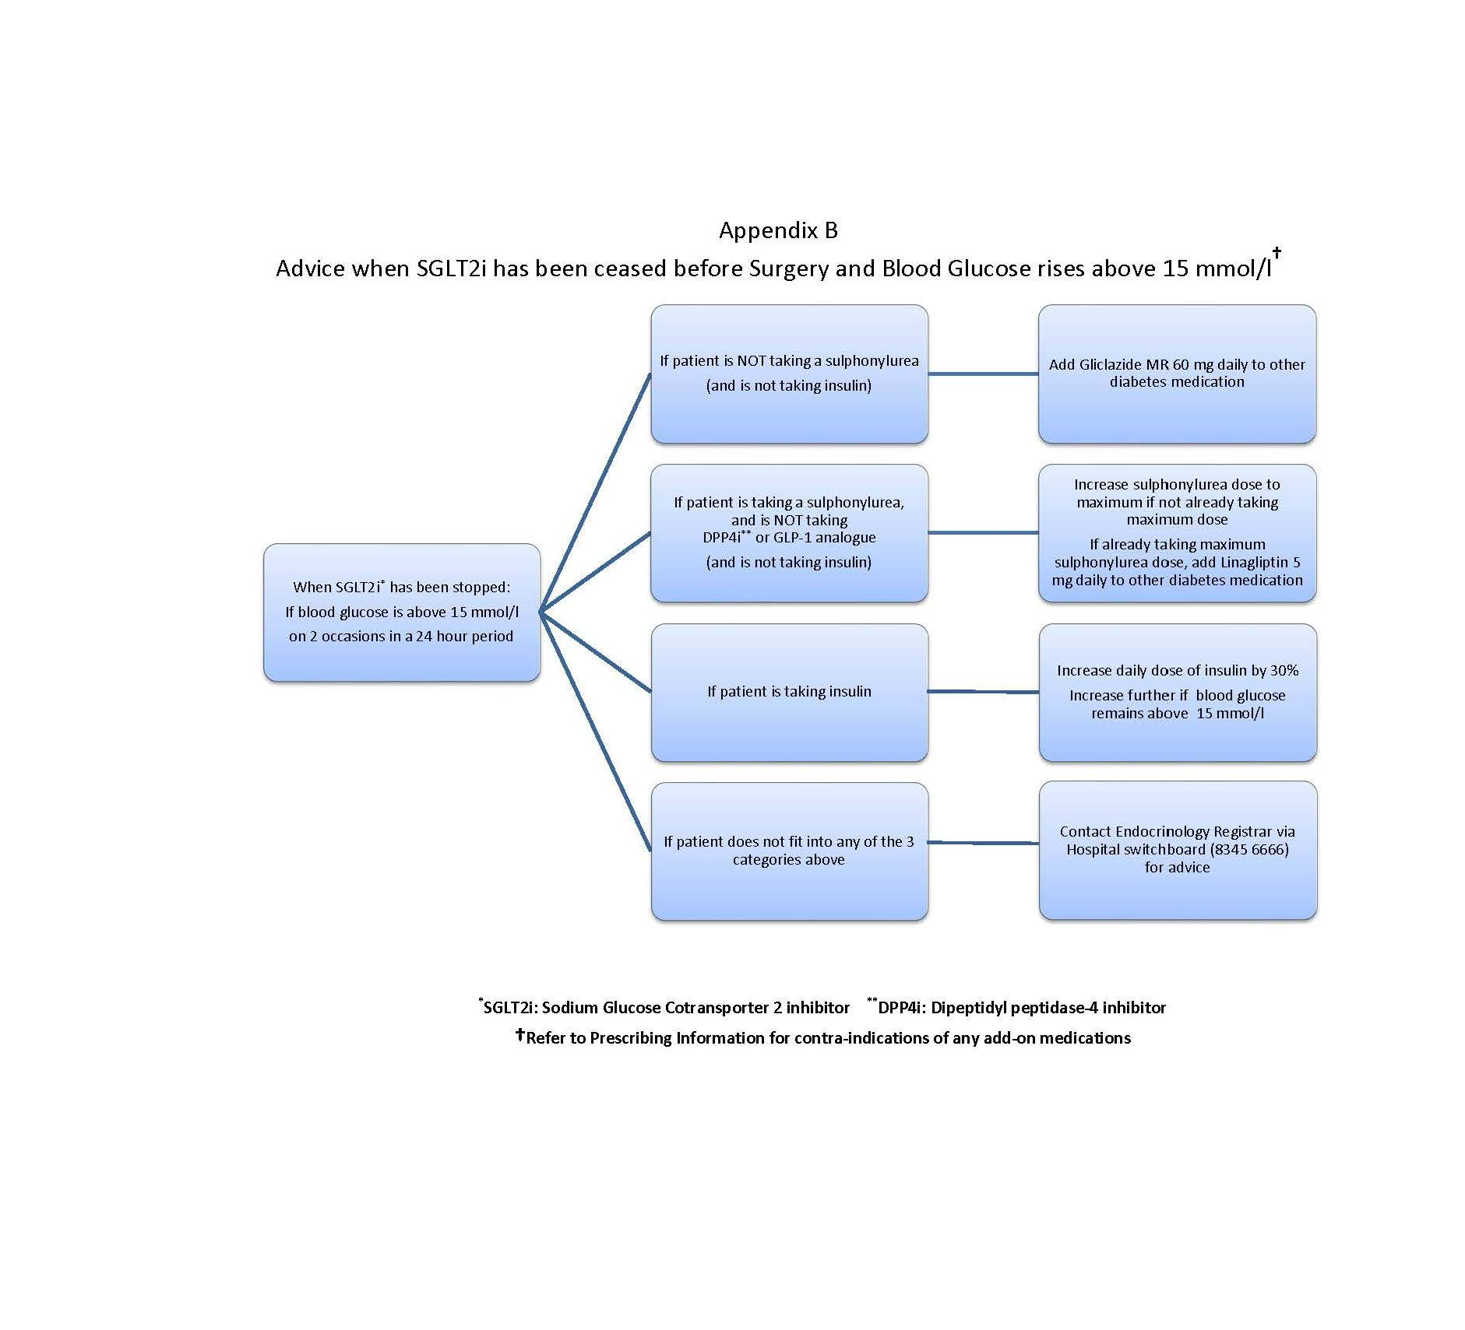

Appendix C
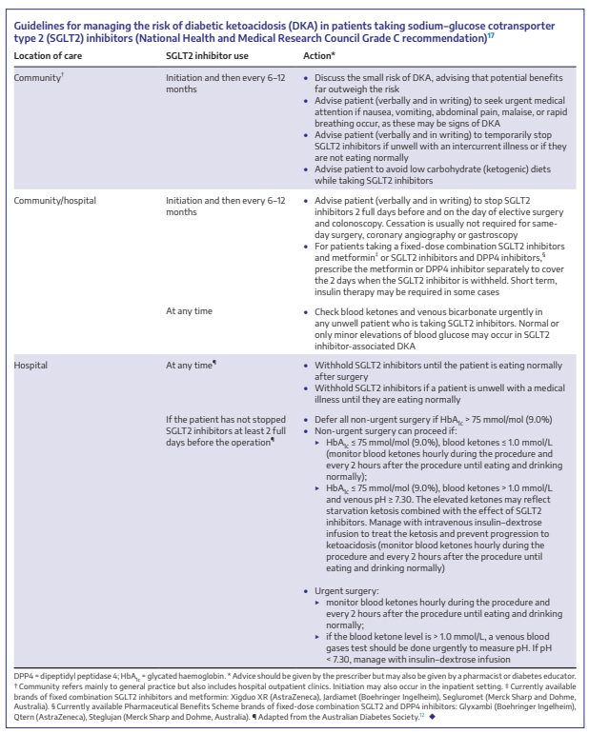
From: Hamblin PS, Wong R, Bach LA Sodium–glucose cotransporter type 2 inhibitors: managing the small but critical risk of diabetic ketoacidosis. Medical Journal of Australia 212(7) April 2020: 294-296.e1
https://doi-org.ezproxy.wh.org.au/10.5694/mja2.50525

Appendix D
TABLE 1: ORAL HYPOGLYCAEMICS & GLP-1 ANALOGUES |  |  |  | TABLE 2: INSULINS
Generic name | Trade name | Recommend |  | Generic name | Trade name | Recommend
 |  |  |  |  |  | IF: AM LIST  (no breakfast) | IF: PM LIST  (light breakfast)
Biguanides  Metformin | Diabex (XR), Formet  Diaformin, Glucobete | Withhold all on the day of procedure |  | Long acting basal  Insulin glargine  Insulin detemir | Optisulin Toujeo  Levemir | If usually takes basal nocte only *  Take usual dose night before procedure | If usually takes basal nocte only *  Take usual dose night before procedure
 |  |  |  |  |  | If usually takes basal mane only  Take usual mane dose on the morning of procedure | If usually takes basal mane only  Take usual mane dose on the morning of procedure
Sulphonylureas  Gliclazide  Gliclazide MR  Glibenclamide  Glimepiride  Glipizide  Glitazone  Pioglitazone  α1Glucosidase inhibitors  Acarbose  DDP4 inhibitors  Sitagliptin  Vildagliptin  Linagliptiin  Saxagliptin  Alogliptin  GLP1 analogues  Exenatide  Dulaglutide  Semaglutide | Glyade, Nidem  Diamicron MR  Daonil  Amaryl, Aylide  Minidiab, Melizide  Actos  Glybosay  Januvia, Janumet¹  Galvus, Galvumet¹  Trajenta, Trajentamet¹  Onglyza, Kombiglyze¹  Nesina, Nesinamet¹  Byetta  Trulicity  Ozempic
 |  |  |  |  |  | If usually takes bd basal  Take usual nocte dose the night before & half mane dose on the morning of procedure | If usually takes bd basal  Take usual nocte dose the night before & half mane dose on the morning of procedure
 |  | Withhold all on the day of procedure |  | Intermediate acting  basal  Isophane insulin | Protaphane  Humulin NPH | Take half usual mane dose | Take half usual mane dose
 |  | Withhold all on the day of procedure |  | Rapid  Insulin aspart  Insulin lispro  Insulin glulisine  Insulin regular  Insulin neutral | Novorapid; Fiasp  Humalog  Apidra  Actrapid  Humulin R | Withhold rapid acting insulin on the morning of procedure | Take half usual mane rapid acting insulin dose on the morning of procedure
 |  |  |  | Pre-mixed insulin  Aspart/protamine Lispro/protamine  Regular/isophane  Degludec/aspart | Novomix 30  Humalog Mix 25  Humalog Mix 50  Mixtard 30/70  Mixtard 50/50  Ryzodeg | Withhold & substitute with  half usual mane dose as intermediate-acting Protaphane insulin  upon admission | Administer half usual mane pre-mixed insulin dose with breakfast meal
 |  |  |  | * nocte basal insulin dose can be decreased by up to 25% if concern of hypoglycaemia on the morning of procedure
SSGLT2 inhibitors  Empagliflozin  Dapagliflozin  Ertugliflozin | Jardiance, Jardiamet²  Glyxambi³  Forxiga, Xigduo², Qtern³  Steglatro,Segluromet², Steglujan³ | Withhold 2 days prior to, and on the day of procedure

¹ Fixed dose combination containing DPP4 inhibitor & metformin

² Fixed dose combination containing SGLT2 inhibitor & metformin

³ Fixed dose combination containing SGLT2 inhibitor & DPP4 inhibitor
Acknowledgement: Appendix D adapted from Royal Melbourne Hospital Peri-operative Diabetes Guidelines

