
PHYSIOTHERAPY DEPARTMENT

CONSERVATIVE MANAGEMENT:
Acute Achilles Tendon Rupture

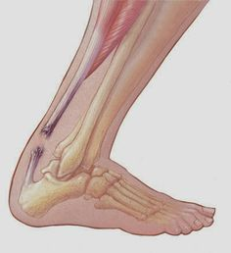

Initial:
Camboot on at all times (3 heel raises), weight-bear as pain allows (use crutches to help)

At 2 weeks:
Remove 1 heel raise (2 heel raises remain), camboot on at all times, weight-bear as pain allows (use crutches to help if needed)

At 4 weeks:
Remove 1 heel raise (1 heel raise remain), camboot on at all times, weight-bear as pain allows (use crutches to help if needed)

At 6-7 weeks:
Remove final heel raise, camboot on at all times when walking. Use crutches if needed.
Can remove camboot for sleeping & exercises as guided by physiotherapist
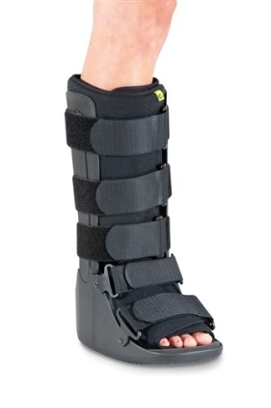
At 10 weeks:
Wean camboot (as guided by physiotherapist)

6 months onwards:
Return to sport (as guided by physiotherapist)

(The above time frames are an estimate and progressions will depend on symptoms)

PHYSIOTHERAPY CONTACT DETAILS:
Footscray Hospital: 8345 6661
Sunshine Hospital: 8345 0268
Williamstown Hospital: 9393 0198

