How to generate an eReferral to Community Services

- In BOSSNET, click on ”Search” > “Find Patient & Episode”
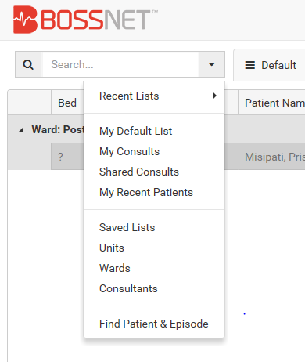

- Enter patient UR and click “Search”
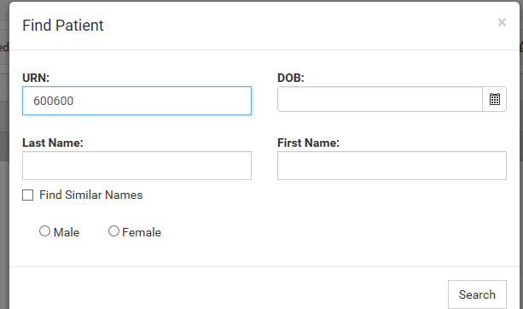

- Click once on the CURRENT episode i.e. the inpatient episode related to your referral. (it will turn blue). Then click on “Select”. 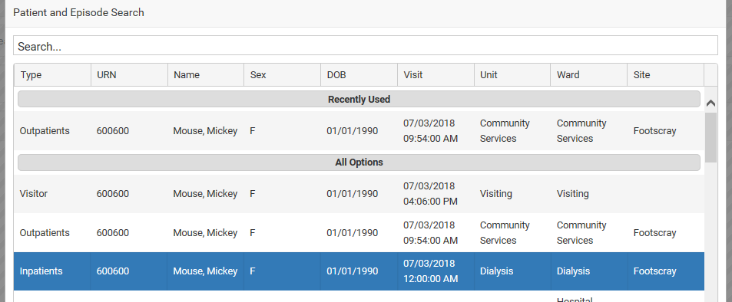

- Click once on the patient line.

- In “Search”, type “Community”. Then click the star on WH Community Services Referral Summary. This will add this to your “Favourites” list, so that you can automatically pick it up from there next time.
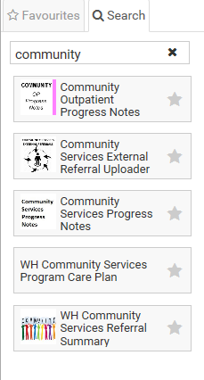
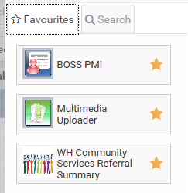

- Click on the WH Community Services Referral icon. This will open a new referral. Note that your ward/referral episode will be clearly displayed.
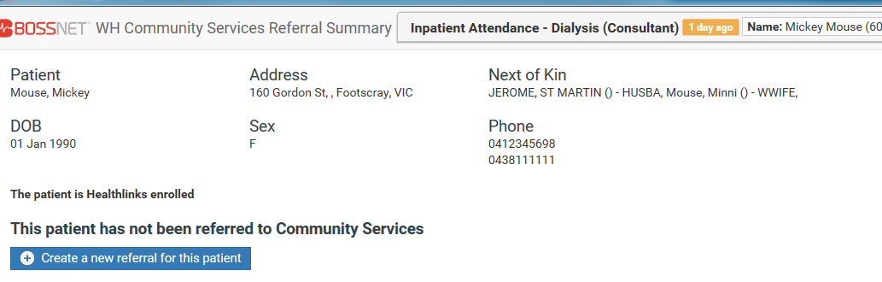

Note: If there is already a referral in progress you will see this, simply click on “Additional Service Request” to add to an existing referral.
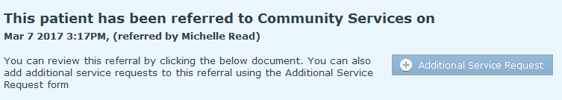

- Enter your discipline, contact details, check consent yes or no, whether an interpreter is required and which language.
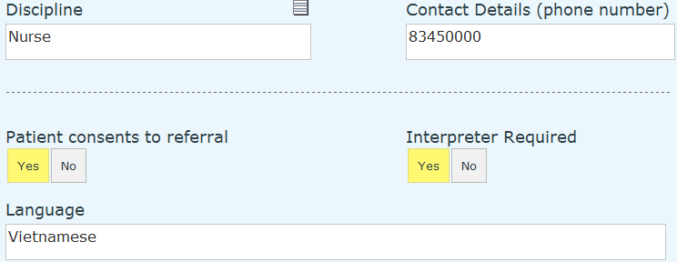

- Enter discharge date, discharge destination.
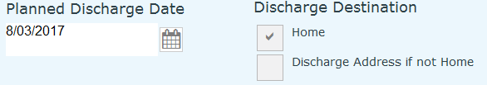

If discharge address is different to home address, check the box and type in the address.
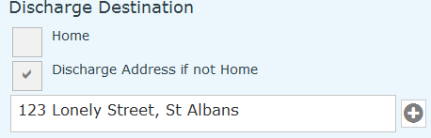

- Select a Priority, see guide.
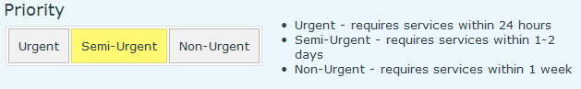

- Complete Discharge Planning Score, this will generate a referral to Inpatient Care Coordination for complex patients.
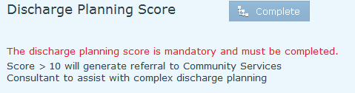

Select Disability, Living Status and Walking Limitation, use guide if required
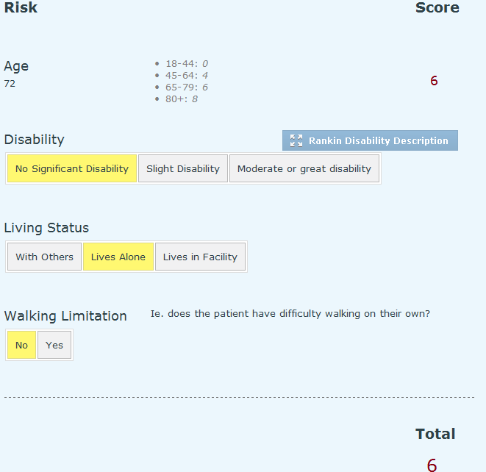
Click “Submit” in the bottom R) corner  Then click “Next” 

- Complete the ISBAR information. (The pink fields are mandatory).
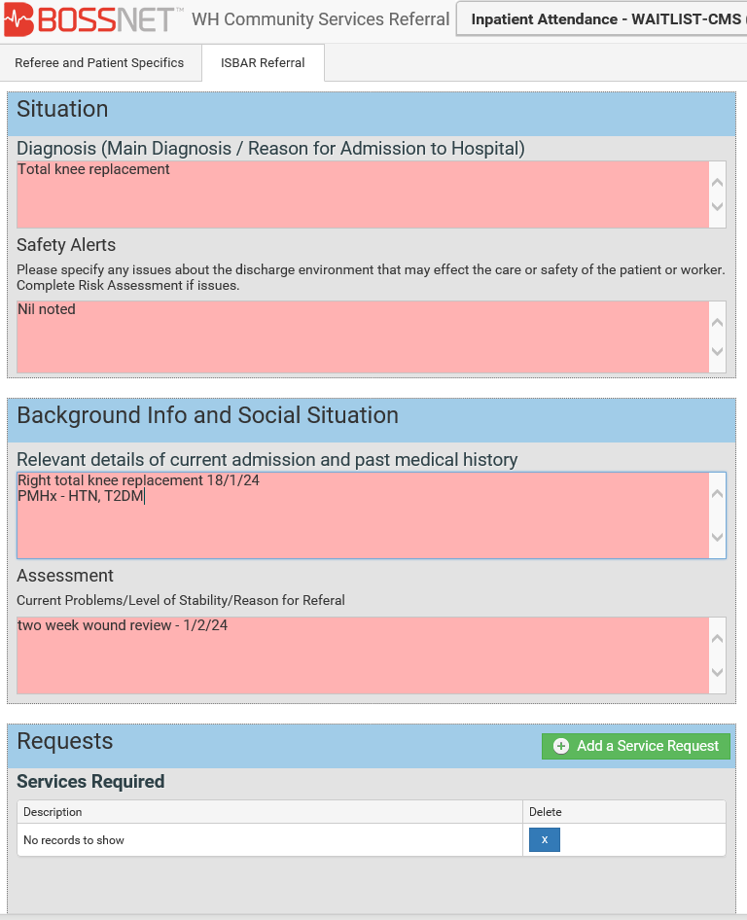

- Click on “Add Service Request” 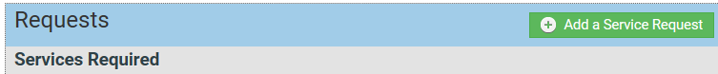

- Select the service required for your patient. Add clear and specific reasons/needs and add other relevant info to the “Additional ISBAR” box.

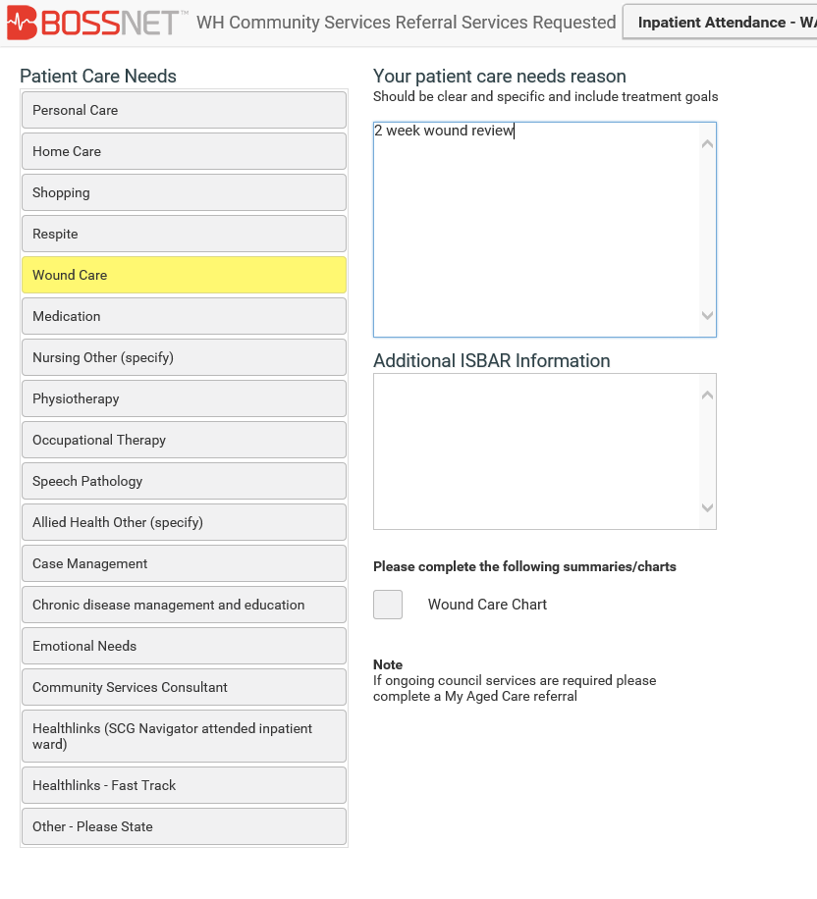

Click on “Submit”.
Only one service can be requested at a time. If your patient requires other services, repeat steps 11 and 12.
- Click on “Submit”. 
Your referral is complete. Click on “Continue” to exit the referral.
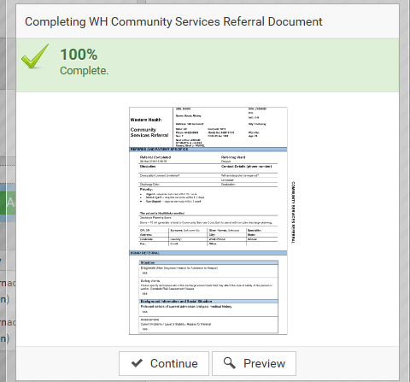

You will be able to view the state of referrals you have made by clicking “Worklists”on the main screen.

Click on Referrals made:

