As part of the survey at the follow-up timepoints at 6 months, 12 months and 24 months after the surgery., patients will be asked to indicate whether they wish to see the surgeon again. This question is “required”. That means patients must provide a response to complete the survey successfully.

Below is an example with joint and side details pre-populated into the question:
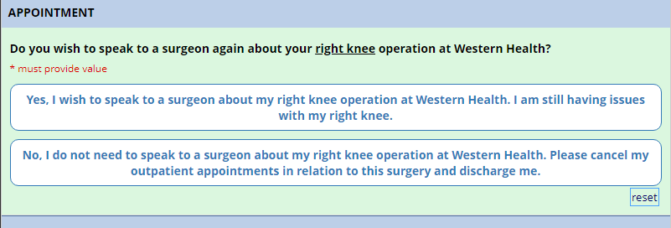
If “Yes” is selected, the patient will be asked to explain their concerns, whether they have discussed issues with the GP and whether they have had a recent X-ray completed.

If “No” is selected, the following message will explain to the patient what it means by providing this response. Please note that the text in red is not presented to the patient – it is just shown for explanation here.

